# **ANALYTICAL REPORTING OF PIZZA SALES - SQL**

## **KPI’s**

### **Total Revenue**

Query:

select sum(total_price) as total_revenue from pizza_sales

Result:

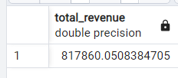

### **Average Order Value**

Query:

select sum(total_price)/count(distinct order_id) as average_order_value from pizza_sales

Result:

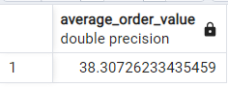

### **Total Pizzas Sold**

Query:

select sum(quantity) as total_pizzas_sold from pizza_sales

Result:

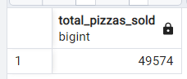

### **Total Orders**

Query:

select count(distinct order_id) as total_orders from pizza_sales

Result:

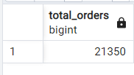

### **Average Pizzas Per Order**

Query:

select round((sum(quantity)*1.0) /(count(distinct order_id)*1.0),2) as average_pizzas_per_order from pizza_sales

Result:

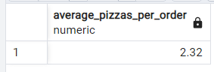

## **Hourly Trend for Total Pizzas Sold**

Query:

select extract(hour from order_time) as order_time ,sum(quantity) as total_orders

from pizza_sales

group by 1

order by 1

Result:

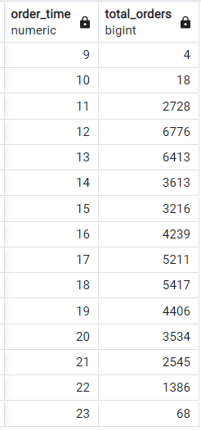

## **Weekly Trend for Total Orders**

Query:

select extract(week from order_date) as week_number,extract(year from order_date) as order_year, count(distinct order_id) as total_orders

from pizza_sales

group by 1,2

order by 1

Result:

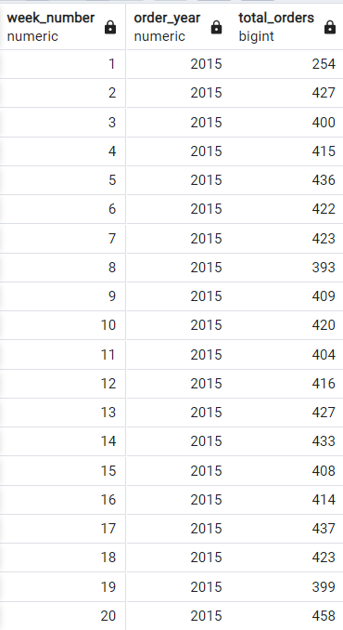 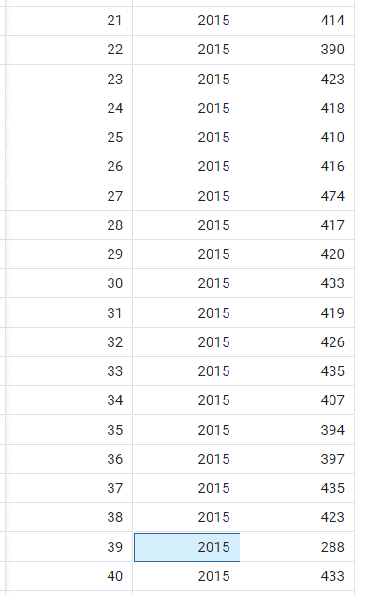

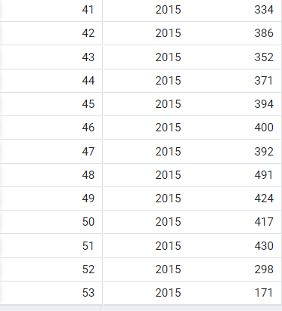

## **Percentage of Sales by Pizza Category**

Query:

select pizza_category,cast(sum(total_price) as decimal(10,2)) as total_sales, cast((sum(total_price) * 100.0/ (select sum(total_price) from pizza_sales)) as decimal(10,2)) as percentage_of_total_sales

from pizza_sales

group by 1

order by 1

Result:

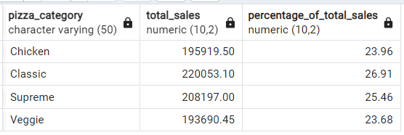

## **Percentage of Sales by Pizza Size**

Query:

select pizza_size,

cast(sum(total_price) as decimal(10,2)) as total_sales,

cast((sum(total_price) * 100 /(select sum(total_price) from pizza_sales)) as decimal(10,2)) as percentage_of_total_sales

from pizza_sales

group by 1

order by 3 desc

Result:

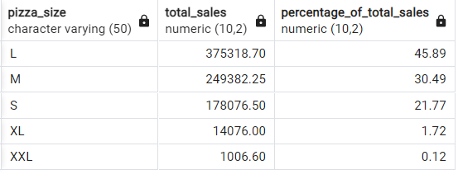

## **Total Pizzas Sold by Pizza Category**

Query:

select pizza_category,sum(quantity) as total_sales

from pizza_sales

group by 1

order by 2 desc

Result:

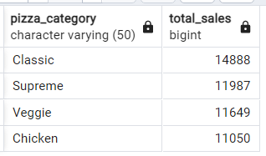

## **Top 5 Best Sellers by Revenue, Total Quantity and Total Orders**

### **By Revenue**

Query:

select pizza_name,sum(total_price) as total_revenue

from pizza_sales

group by 1

order by 2 desc

limit 5

Result:

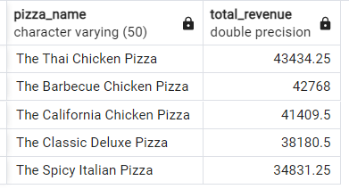

### **By Total Quantity**

Query:

select pizza_name,sum(quantity) as total_quantity

from pizza_sales

group by 1

order by 2 desc

limit 5

Result:

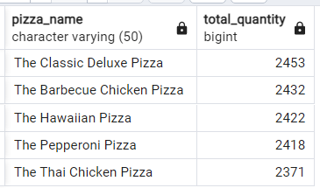

### **Total Orders**

Query:

select pizza_name,count(distinct order_id) as total_orders

from pizza_sales

group by 1

order by 2 desc

limit 5

Result:

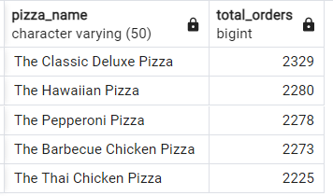

## **Bottom 5 Best Sellers by Revenue, Total Quantity and Total Orders**

### **By Revenue**

Query:

select pizza_name,sum(total_price) as total_revenue

from pizza_sales

group by 1

order by 2 asc

limit 5

Result:

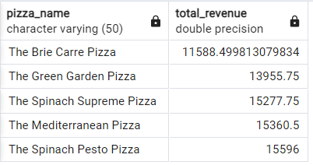

### **By Total Quantity**

Query:

select pizza_name,sum(quantity) as total_quantity

from pizza_sales

group by 1

order by 2 asc

limit 5

Result:

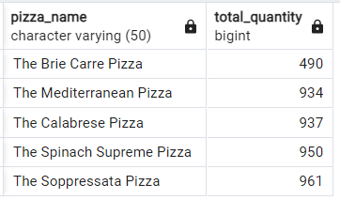

### **Total Orders**

Query:

select pizza_name,count(distinct order_id) as total_orders

from pizza_sales

group by 1

order by 2 asc

limit 5

Result:

